

|  |  |
| --- | --- |
|  |  |
| Student Name: | Ramon Baiao  Varun Kummar Dommaraju |
| Deliverable: | Exercise 2: Cardinality with Zoo Db |
| Course Name: | Business Data Analysis |
|  |  |
| Date Assigned: | Class 5 |
| Date Due: | Class 7 |
| Rules: | 1. You must work with one (1) partner. A team of two (2) people.    1. You are not allowed to complete this exercise individually.    2. If there is an odd number of students in a class then there may be a single (1) group of three (3) students. To form this group you MUST receive Instructor permission. 2. You may use any reference materials that you would like! 3. You may not share your work with other teams, nor take the work of other teams. 4. FAILURE to submit work in the course can result in a grade of ‘I’ for the course! Ensure that you submit all deliverables. |

Objective

The Entity Relationship Diagram (ERD) is a tool used to help organize the logical structure of a relational database, representing said structure in a graphical manner to reduce complexity and effectively communicate the;

* relationships
* entity attributes
* functionality of a database system

Pass on to another

Scenario – Fun with Cardinality

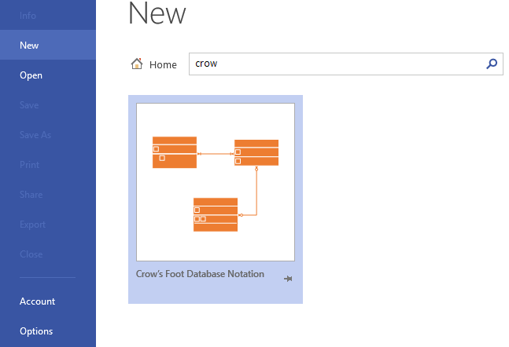Your goal is to build a logical design, an ERD, for the zoo database that you have made use of for your previous exercise. One of our roles as ITBAs will be to collect, refine and verify that the design of a current or future database is both functional and hosts valid relationships. Please note that the Database has already been normalized and does not require further refinement or modification of the existing tables.

Deliverables

Using VISIO and the built-in Crow’s Foot Notation template you will apply the principles of Cardinality to the logical design of the Zoo database. Recreate the Zoo_Database’s tables within VISIO showing the relationships and cardinality that exist between these tables.

Your deliverable must include the following elements:

* Functional requirements
  + All tables represented by the Zoo_Database must be included
  + All fields within each table must be included and labelled as they appear within the database
  + Each table name should be labelled with their corresponding name which must be clearly visible
  + Cardinality must be clearly visible and legible, symbols for cardinality are to be lined up to the exterior of the table
  + All Primary Keys and Foreign Keys must be clearly identified
  + Attribute Types must be included
* Formatting
  + Your name along with your partners
  + The date, course title, and exercise name must be listed on your ERD submission
  + Ensure that your finished ERD is presented in a professional manner, paying attention to clarity of layout
  + All text must be a minimum of size 10 font

Evaluation

Your evaluation will be held to the following rules and constraints. These rules are firm and are irrefutable.

* Failure to submit this completed deliverable will result in a grade of zero (0) on this deliverable.
  + There will be no opportunity provided to make up for this missed deliverable or raise your grade.
  + In the instance that the failure to submit this work results in a grade of zero (0) that ultimately causes an overall course grade below fifty-five (55) then there will be no opportunity to perform any work, tests, activities or tasks to raise your grade above the failing mark.
* It is the student’s responsibility to ensure that their work has been submitted through eConestoga, on-time, to the correct course and in the correct folder.
  + If you submit your work to the incorrect folder then you may not receive any grade for your work. This will be completely up to the discretion of your Instructor.
  + If you, the student, submit your file to the wrong folder or course on eConestoga then you must simply resubmit to the correct folder.
* To pass this course you are required to submit every single deliverable.
  + If you have failed to submit any work by the end of the course your Instructor reserves the right to assign a final course grade of incomplete (I) or failure (F) for your performance in the entire course.

Your work, once submitted through eConestoga, will be evaluated based on the following criteria.

* 1 point per correct maximum cardinality. (8 points total)
* 1 point per correct minimum cardinality. (8 points total)
* 4 points total for adhering to the formatting rules. (4 points total)

Please note that professionalism of presentation, while not a specific evaluation criterion, may influence your overall grade for this deliverable if the work produced is significantly lower, or higher, than what would be expected from a professional submission. Items that will be taken into consideration as part of professionalism would include:

* Sentence structure and grammar
* Spelling
* Clear formatting
* Choice of language and terminology
* Clarity of structure (readability)

Submission Details

|  |  |  |
| --- | --- | --- |
| **SUBMISSION LOCATION** |  | **SUBMISSION SPECIFICS** |
| |  |  | | --- | --- | | Course: | Business Data Analysis | | Submission: | Dropbox | | Folder: | Exercise #2 | | Work Type: | Teams of 2 students | | File Type(s): | PDF | | # of Files: | 1 | |  | One (1) member of your team must submit the team exercise through eConestoga. Please identify your name and the name of your group member in the comments section within the dropbox. Failure to do this may result in a group member not receiving a grade on their work. |

**FILE NAMES**

All submissions must adhere to the programs naming convention. For details regarding this naming convention documentation can be retrieved from the *How-To* module, within the *Support* module for your course on eConestoga, file name “O3 - Student Submissions Naming Convention - ver1.0.PDF.” If this is group work you must include your group members names within your work and within the NOTES section of your dropbox submission. Submitting your work with an improper file type may result in a grade of zero (0) being assigned.

**ACADEMIC HONESTY**

1. By submitting your work through Conestoga College’s eConestoga dropbox you hereby affirm that;
   1. You are in complete understanding of, and accept in full, the *Academic Integrity Policy* and *Violation of Academic Integrity Policy* of Conestoga College. If you are not familiar with these policies it is your responsibility to familiarize yourself with them, in full, before submitting any work through eConestoga.
   2. The work that you have submitted is your own work and has not been: taken, replicated, duplicated or copied in any way from any source inside or outside of the classroom.
   3. Your work will be retained and indexed by Turnitin.com for academic honesty and comparison purposes.
2. If you share your work with, or use the work of, others then your grade, along with the grade of any other participating[1] student, will be adjusted to reflect this infraction and you will face academic penalties[2] including, but not limited to;

* Discontinuance for Conestoga for a minimum of 12 months and a failing grade for all current courses.
* A failed grade for the course and suspension from Conestoga College for an undetermined length of time.
* A failed grade for the course, which may result in your inability to continue in your Program.
* A failed grade for the deliverable on which the *Academic Integrity Policy* was violated.

1. Turnitin.com will compare the values and data of each student submission against submissions from;

* Your current classmates, including all submissions they have made in the past or present.
* Former students of your program as well as students from other intakes for your program.
* Students enrolled in any course or program at Conestoga College, past or present.
* A perpetually growing database of work from 26 million students from Colleges and Universities worldwide.
* More than 12 **b**illion webpages including all mainstream data sites, repositories and wikis.
* Direct quotations taken from any source will be identified by Turnitin.com and will require Instructor review, it is, therefore, imperative that you cite any work(s) taken from other sources following proper APA format.

1. Participation includes both unknowing participation as well as willful participation in any activity that results in academic misconduct.
2. No refunds will be made available to any student who has been discontinued from their program due to violations of academic policy.